__________________________________________________________________

**Central Florida Regional Planning Model**

**Version X.X**

**Model Description Report**

__________________________________________________________________

**NAME**



**Prepared for the**

**Florida Department of Transportation**

**Updated By**

**Firm**

**Address**

**DATE**

Table of Contents

1 Introduction 1

1.1 Regional Travel Patterns 2

1.2 Version x.x Updates 2

1.2.1 Usage of the CFRPM Vx.x Model 3

2 Traffic Analysis Zones and socio-economic Data 4

2.1 TAZ Development 4

2.2 Household Data 4

2.2.1 Data Sources 4

2.2.2 Data Description and Validation 4

2.3 Employment Data 6

2.3.1 Data Sources 6

2.3.2 Data Description and Validation 6

2.4 Special Generator Data 7

2.4.1 Data Sources 7

2.4.2 Data Description and Validation 7

2.5 Classification Sub-models 7

2.5.1 Vehicle Ownership 7

2.5.2 Household Classification 7

2.5.3 Area Type Definitions 8

3 Network Development 9

3.1 Highway Networks 9

3.1.1 Speed 10

3.1.2 Development and Checking of Highway Paths 10

3.1.3 Capacity Calculation 10

3.2 Traffic Counts 10

3.3 Transit Networks 11

3.3.1 Transit Route Coding 11

3.3.2 Transit Speeds 11

3.3.3 Development and Checking of Transit Paths 11

3.3.4 Access Links 11

4 Household Travel Survey and Trip Generation 12

4.1 Household Survey Analysis 12

4.1.1 Data Review, Preparation and Processing 12

4.1.2 Data Adjustments or Re-expansion 12

4.2 Trip Production Model 12

4.2.1 Trip Purpose Determination/Market Stratification 12

4.2.2 Trip Rate Determination 12

4.2.3 Special Market Models 12

4.2.4 Validation and Comparisons 12

4.3 Trip Attraction Model 12

4.3.1 Trip Attraction Rate Determination 12

4.3.2 Special Markets 12

4.4 Trip Adjustments and Balancing 12

4.5 Validation and Comparisons 12

5 Trip Distribution 13

5.1 Datasets and Analysis 13

5.2 Model Assertion & Stratification 13

5.3 Model Utility 13

5.3.1 Terminal Times/Intrazonal Travel Time Calculations 13

5.3.2 Friction Factor Definition 13

5.4 Model Calibration and Adjustments 13

6 Truck/Commercial Vehicles 14

6.1 Truck Datasets 14

6.2 Trip Generation 14

6.3 Trip distribution 14

6.4 Calibration 14

7 External Models 15

7.1 EE Trip Model 15

7.1.1 External Trip Data 15

7.1.2 Station Locations 15

7.1.3 External EE Trip Model Estimation 15

7.2 E-I Model 15

7.2.1 EI Trip Generation 15

7.2.2 EI Trip Distribution 15

7.2.3 Time of Day 15

7.2.4 EI Calibration Results 15

8 Time of day 16

8.1 Diurnal Factors by Trip Purpose: 16

8.2 Peak Period Determination 16

8.3 Time of Day and Directional Split Factors 16

8.3.1 Factors for Resident Trips 16

8.3.2 Factors for Commercial Vehicles 16

8.3.3 Factors for External Trips 16

9 Transit Data and Analysis 17

9.1 On-Board Survey 17

9.1.1 Survey Analysis 17

9.1.2 Sample & Survey Expansion 17

9.1.3 District Summaries 17

9.1.4 Calibration Targets 17

9.2 Transit Data 17

9.2.1 Transit Modes 17

9.3 Transit Paths 17

9.3.1 Path-Cost Components 17

9.3.2 Transit Skims 17

10 Mode Choice Model Structure 17

10.1.1 Mode-Choice Description 17

10.1.2 Asserted Model Coefficients 17

10.2 Mode-Choice Model Calibration & Results 17

10.2.1 Primary Calibration of Mode Choice Constants 17

10.2.2 Calibration of CBD Attraction Transit Trips/Additional Adjustments 17

10.2.3 Calibration Results & Comparisons 17

10.3 Model Validation 17

10.3.1 Aggregate 17

10.3.2 Route Level 17

11 Highway Assignment 18

11.1 Assignment Methodology 18

11.1.1 Autos 18

11.1.2 Trucks/Commercial Vehicles 18

11.1.3 External-internal 18

11.2 Volume Delay Curve Development 18

11.3 Traffic Assignment Capacity Factors 18

11.4 Model Adjustments 18

List of Tables

Table 1: CFRPM Household Data Elements 5

List of Figures

Figure 1‑1: CFRPM Model Flow Diagram 1

Figure 1‑2: Example Model Boundary 2

Figure 3‑1:Example Highway Path Check 10

List of Appendices

**No table of contents entries found.**

List of Acronyms

***Modify as necessary: Some Examples Given***

ACS American Community Survey

DOT Department of Transportation

ESC Employment Security Commission

FAF Freight Analysis Framework

FHWA Federal Highway Administration

FIPS Federal Information Processing Standard

HBO Home-Based Other Trips

HBW Home-Based Work Trips

HBS Home-Based Shop Trips

MPO Metropolitan Planning Organization

NAICS North American Industry Classification System

NHB Non-Home-Based Trips

NHO Non-Home Other Trips

NHW Non-Home Work Trips

NHTS National Household Travel Survey

SAS Statistical Analysis System

TAZ Transportation analysis zone

# Introduction

* General introduction of the CFRPM model and the history of the recent versions.
* This will include an executive summary discussion of the model design that provides two or three sentences on each of the major components listed here:
  + Socio-Economic Data
    - Vehicle Ownership model
  + Networks
  + Trip Generation
  + Trip Distribution
  + Mode Choice
  + Traffic Assignment
  + Truck Model
  + Feedback Loop
* Including a graphic of the overall model flow as shown below.
* The horizon years of this model version should be included here

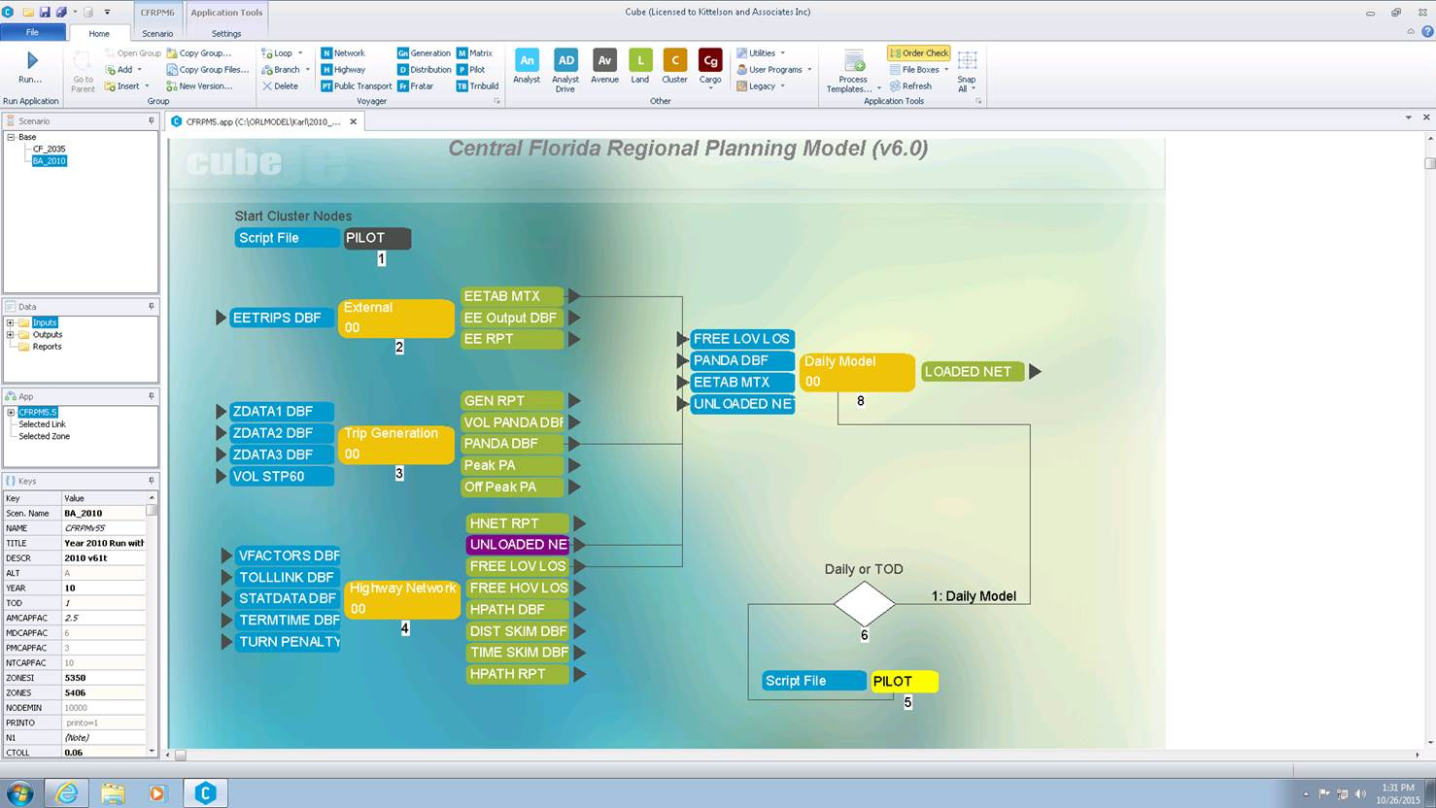

Figure ‑: CFRPM Model Flow Diagram

Example of the general intro information needed:

The CFRPM is a traditional four step model that includes trip generation, trip distribution, mode choice and traffic assignment. Additional components that are included in the model include a household model which develops household distributions required by the trip generation as well as separate truck and external models. The model includes a Time of Day structure that includes four periods: AM peak (6am to 9am), midday (9am to 2pm), PM peak (2pm to 6pm) and overnight. Some unique features of each model component are included below:

“Description details of key model components”

1. Visitor Model
2. etc

* A map of the model boundaries should be included in this section as well. Example below

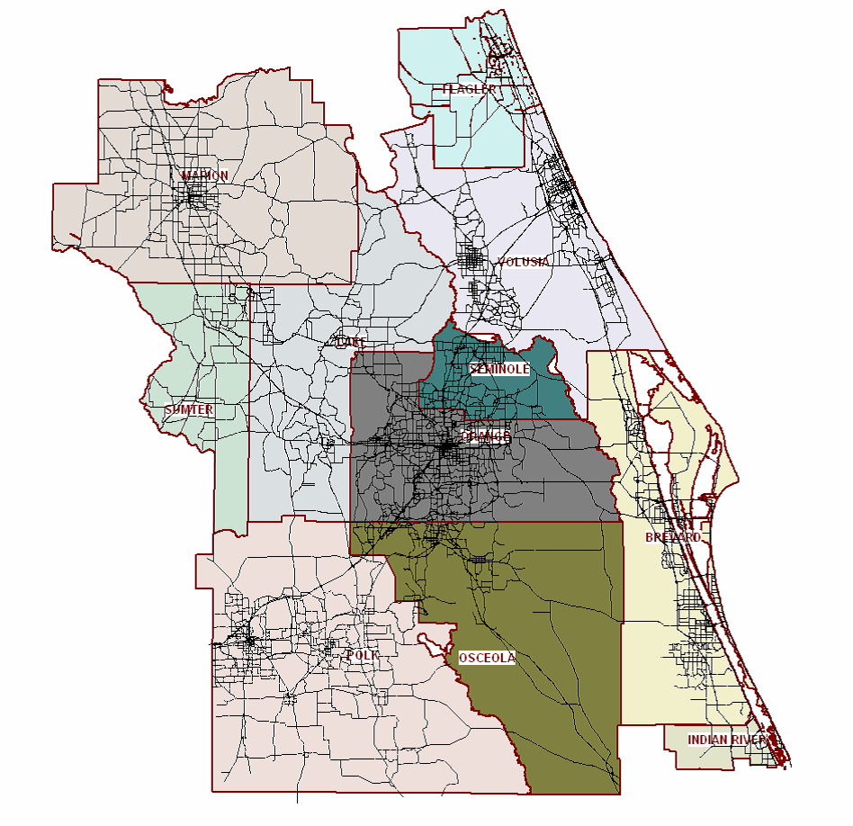

Figure ‑: Example Model Boundary

## Regional Travel Patterns

Using non-technical terms provide an overview of the key travel markets and patterns, how those have evolved and how this model version is attempting to address those markets.

## Version x.x Updates

This section would define what has changed in this version of the model. This should provide a few paragraphs of detailed summary to allow the reader to understand the overall changes.

Include development dates of this version

A numbered bulleted list of the changes should be included in this section and linked to the proper location in the documentation.

1. Time of Day Periods added
2. New Assignment Methodology
3. etc

### Usage of the CFRPM Vx.x Model

* Define how the newly changed components should or should not be used.
* Include example(s) of the intended analysis abilities by providing real world tests if possible

# Traffic Analysis Zones and socio-economic Data

## TAZ Development

* Discussion of the number of TAZs and how they were chosen and explanation of the numbering system.
  + Include chart to show reserved dummy nodes if applicable
* Map of the TAZs and external station locations should be provided
* Include a summary of TAZs by type as well as by county or region. An example is shown below:

|  |  |  |
| --- | --- | --- |
| Summary | TAZs | TAZ Range |
| Internal | 174 | 1-499 |
| External | 25 | 501-530 |
| Total | 198 | ------ |

## Household Data

### Data Sources

* Descriptions of the sources of the datasets used for the development of HH data
  + Include links/references to original dataset where applicable

### Data Description and Validation

* Description of the revisions/cleaning of these datasets including documentation of adjustments made to input data and why they were necessary.
  + If adjustments are made to data they should be documented using the following outline:
    - Purpose of the Adjustment
    - Methodology Used
    - Results of Adjustment
      * Example figures of issues determined and how resolved if applicable
* Reference to additional validation datasets were applicable
* Table to show data elements as shown

Table : CFRPM Household Data Elements

|  |  |  |  |
| --- | --- | --- | --- |
| Data Element | Description | Where Obtained | Manual Adjustments Required |
| TAZ | TAZ Numbers |  |  |
| SFDU | Single Family Dwelling Units | Census data | no |
| SF_PCTVNP | Percentage of Single Family are Vacation and Non Permanent Resident Homes |  |  |
| SF_PCTVAC | Percentage of Single Family are Vacation Homes |  |  |
| SFPOP | Single Family Population |  |  |
| SF_0AUTO | Single Family Percentage of 0 Auto |  |  |
| SF_1AUTO | Single Family Percentage of 1 Auto |  |  |
| SF_2AUTO | Single Family Percentage of 2+ Auto |  |  |
| MFDU | Multiple Family Dwelling Units |  |  |
| MF_PCTVNP | Percentage of Multiple Family are Vacation and Non Permanent Resident Homes |  |  |
| MF_PCTVAC | Percentage of Multiple Family are Vacation Homes |  |  |
| MFPOP | Multiple Family Population |  |  |
| MF_0AUTO | Multiple Family Percentage of 0 Auto |  |  |
| MF_1AUTO | Multiple Family Percentage of 1 Auto |  |  |
| MF_2AUTO | Multiple Family Percentage of 2+ Auto |  |  |
| HMDU | Hotel Motel Dwelling Units |  |  |
| HMOCC | Hotel Motel Occupancy Percentage |  |  |
| HMPOP | Hotel Motel Population |  |  |

Or text Example:

Household and population data was obtained from the *2010 Census* *Group SF1*. Data from the block level was summarized to the TAZ level. The following SE data fields were obtained from this source:

* Households – total number of households within the TAZ
* Population – total number of people living within the TAZ

Population = GQ_Population + HH_Population

* GQ_Population – total number of people living in Group Quarters within the TAZ
* HH_Population – total number of people living in households within the TAZ
* Include in Appendix the final numbers used for every TAZ as a reference

## Employment Data

* General Description of the datasets used and how they are used in the model

Example:2010 employment data was obtained from InfoGroup and then verified by random sample checking the number of employees by phone or based on personal knowledge. Upon the completion of this process, staff members created a geocoded employment database that included each employer by name, physical address, number of employees and employment type. Employment type was grouped into five main categories.

### Data Sources

* Descriptions of the sources of the datasets used for the development of employment data
  + Include links/references to original dataset where applicable

### Data Description and Validation

Detailed definitions for employment groupings including the NAICS codes. Example shown below.

* Industrial (SIC Groups 1-49) – Includes employment such as manufacturing, agriculture, construction, and freight services.
* Retail (SIC Groups 50-54, 56, 57, 59) – Includes wholesale trade and retail trade.
* Highway Retail (SIC Groups 55 and 58) – Includes retail that falls into the category of fast food restaurants, service stations, banks, post office and other types of eating and drinking establishments.
* Office (SIC Groups 60-67, 91-97) – Includes finance, insurance, real estate, and governmental type offices.
* Service (SIC Groups 70-76, 78-89, 99) – Employment data falling into this category are generally classified as personal and business services, auto repair, and other service type establishments.

• Description of the revisions/cleaning of these datasets including documentation of adjustments made to input data and why they were necessary.

* + If adjustments are made to data they should be documented using the following outline:
    - Purpose of the Adjustment
    - Methodology Used
    - Results of Adjustment
      * Example figures of issues determined and how resolved if applicable
* Reference to additional validation datasets were applicable
* Table to show data elements

## Special Generator Data

What decisions led to the use of special generators in the model

### Data Sources

* Descriptions of the sources of the datasets used for the development of special generators

### Data Description and Validation

* How were these data assumptions used and validated in the model?
* Table of special generators by zone including:

|  |  |  |  |
| --- | --- | --- | --- |
| **Model TAZs** | **Name of Generator** | **County** | **Type of Generator** |
| 118, 171 | AB Tech-Main Campus | Osceola | College |

## Classification Sub-models

### Vehicle Ownership

* How was the submodel developed?
  + What estimation was done
* What data sets were used and why?
* What validation of the submodel was performed?
* Plots of the resulting curves or outputs from the submodel
  + Plot of ACS vs Model estimation
* Include final coefficients in a table

### Household Classification

* How was the submodel developed?
* What data sets were used and why?
* What validation of the submodel was performed?
* Plots of the resulting curves or outputs from the submodel
  + Include raw and smoothed results
* Validation of submodels depends on stratification but should include:
  + Household Size Submodel Estimated to Observed by County
  + Income Submodel Estimated to Observed by County
  + Workers per Household Submodel Estimated to Observed by County
  + Table of Estimated vs. Observed by District

### Area Type Definitions

* How is area type defined and what values are needed for these calculations
  + How are the area types smoothed
* Plots of resulting area type for verification

# Network Development

## Highway Networks

* What data was used for the network development
* Plots of countywide/regional coded speeds and # of lanes to show validation
* Discussion on the Validation that network paths have been checked
  + Interactive path traces
  + Checking zero volume links
* A description of the fields coded in the network should be provided. This table should be designate which fields are user input versus calculated by the model.

**Example User Input Highway Attribute Data**

|  |  |  |
| --- | --- | --- |
| **Field Name** | **Description** | **User Input or Calculated** |
| Street Name | Common street name | Input |
| Route Number | Common route name | Input |
| AREA_Type | Calculated values of area type | Calculated |
| COUNTY | County name | Input |
| FUN_CLASS | Functional Classification:  0 = not classified  1 = Interstate  2 = Principal Arterial Other Freeway  3 = Principal Arterial Other  4 = Minor Arterial  5 = Major Collector  6 = Minor Collector  7 = Local |  |
| Route Number | Common route name | Input |
| AREA_Type | Calculated values of area type | Calculated |
| COUNTY | County name | Input |
| FUN_CLASS | Functional Classification:  0 = not classified  1 = Interstate  2 = Principal Arterial Other Freeway  3 = Principal Arterial Other  4 = Minor Arterial  5 = Major Collector  6 = Minor Collector  7 = Local |  |

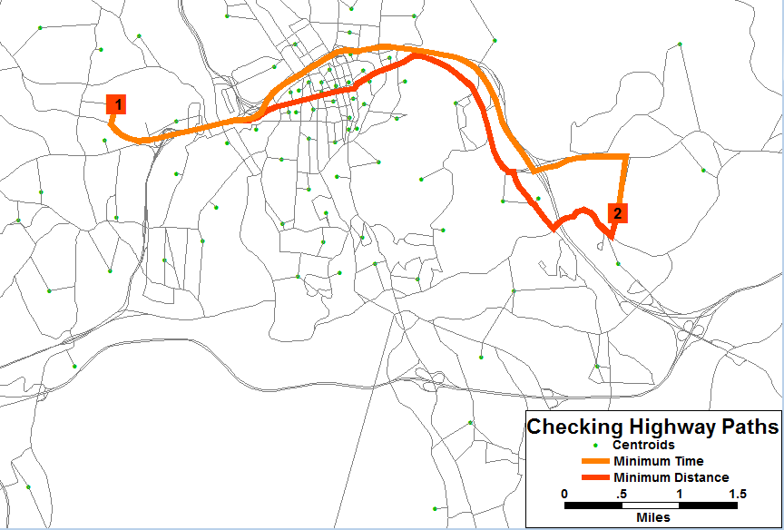

Figure ‑:Example Highway Path Check

### Speed

* How are free flow and default congested travel speeds calculated in the model?
* Table of speed assumptions by facility type should be included.
* Any data used for validation of these speeds?

### Development and Checking of Highway Paths

### Capacity Calculation

* How is capacity calculated?
  + Include formulas/reference and capacity table where appropriate
* What values are needed and how does the model get to peak period capacities?

## Traffic Counts

* Discussion of the count information used in the model. Including year of counts, count types and how the counts were prepared as a part of the model development
  + Table of counts including unique count ID, highway network link ID, count type, count source, road on, location description, and average weekday count (AWDT)
* Map of count location and screenline locations and numbering

## Transit Networks

### Transit Route Coding

* What year & month are the routes from?
* What are the modes coded?
* How many routes coded?
* List of routes including route name, route ID and their peak and offpeak headways so they can be referenced
  + Pdfs of the online route info for reference
* What fare is used?
  + How was the fare calculated

### Transit Speeds

* What speed functions are being used?
* How were they developed/adjusted/calibrated?

### Development and Checking of Transit Paths

* A description of how the paths were verified in the model
* What path builder setting and weights are being assumed

### Access Links

* Details on how are access links coded in the model?
* Included should be a table of the access link coding values and a picture of what they represent

# Household Travel Survey and Trip Generation

## Household Survey Analysis

### Data Review, Preparation and Processing

#### Household Data Summary

#### Person Data Summary

#### Trip Data Summary

### Data Adjustments or Re-expansion

## Trip Production Model

### Trip Purpose Determination/Market Stratification

### Trip Rate Determination

#### Initial/Raw vs Smoothed/Adjusted

### Special Market Models

### Validation and Comparisons

## Trip Attraction Model[1]

### Trip Attraction Rate Determination

#### Estimation/Analysis

#### Initial/Raw vs Smoothed/Adjusted

### Special Markets

## Trip Adjustments and Balancing

## Validation and Comparisons

# Trip Distribution

## Datasets and Analysis

## Model Assertion & Stratification

* Estimated or Borrowed Coefficients

## Model Utility

* Gravity Model or Destination Choice

### Terminal Times/Intrazonal Travel Time Calculations

### Friction Factor Definition

* Function or Lookup table
* District Definitions

## Model Calibration and Adjustments

* TLFD Curves-Estimated vs Observed
* District Summaries

# Truck/Commercial Vehicles

## Truck Datasets

## Trip Generation

## Trip distribution

## Calibration

# External Models

## EE Trip Model

### External Trip Data

### Station Locations

### External EE Trip Model Estimation

## E-I Model

### EI Trip Generation

### EI Trip Distribution

### Time of Day

### EI Calibration Results

# Time of day

## Diurnal Factors by Trip Purpose:

## Peak Period Determination

## Time of Day and Directional Split Factors

### Factors for Resident Trips

### Factors for Commercial Vehicles

### Factors for External Trips

# Transit Data and Analysis

## On-Board Survey

### Survey Analysis

#### Purposes/Demographics

### Sample & Survey Expansion

### District Summaries

### Calibration Targets

## Transit Data

### Transit Modes

#### Transit Access/Egress Connectors

#### Transit Fare

#### Transit Travel Times

## Transit Paths

### Path-Cost Components

### Transit Skims

# 

# Mode Choice Model Structure

### Mode-Choice Description

### Asserted Model Coefficients

## Mode-Choice Model Calibration & Results

### Primary Calibration of Mode Choice Constants

### Calibration of CBD Attraction Transit Trips/Additional Adjustments

### Calibration Results & Comparisons

## Model Validation

### Aggregate

### Route Level

# Highway Assignment

## Assignment Methodology

### Autos

### Trucks/Commercial Vehicles

### External-internal

## Volume Delay Curve Development

## Traffic Assignment Capacity Factors

## Model Adjustments

1. Depends on the model type. If CFRPM moves to best practice destination choice then this would go away and moves into trip distribution.